OVERALL DASHBOARD DESIGN SYSTEM

Layout Framework
- Left Sidebar (Fixed – 260px width)
- Top Header Bar (Sticky – 72px height)
- Main Content Area (Scrollable)
- Right Utility Panel (Optional future – filters/AI insights)
Color theme:
Dark industrial sidebar
Light main content
Blue accents
Orange for action buttons

BUYER DASHBOARD

1️⃣ Buyer Sidebar Structure
🏠 Overview
🔎 Browse Machinery
📨 My Inquiries
📑 RFQs
⭐ Saved Machines
📊 Comparisons
📦 Orders (Future)
💬 Messages
📍 Industrial Hubs
⚙ Settings

2️⃣ Buyer Overview Page (Home)

Top Row – KPI Cards (4 Columns)
Card Style: White background, subtle shadow
- Total Inquiries Sent
- Active RFQs
- Supplier Responses
- Saved Machines

Middle Section – Activity Feed
Left (70% width):
Recent Activity Timeline
- RFQ sent
- Supplier responded
- Price updated
- Message received
Right (30% width):
Quick Actions Panel:
- Post New RFQ
- Browse Categories
- Compare Saved Machines

Bottom Section – Suggested Machines
AI-based recommendations:
“Machines similar to your inquiries”
Horizontal scroll cards.

3️⃣ RFQ Management Interface
Layout:
Top: RFQ Status Tabs
- Draft
- Active
- Negotiating
- Closed
Each RFQ Card shows:
- Title
- Budget range
- Location
- Suppliers responded
- Lowest quote
- Status badge
Click → opens detail page.

RFQ Detail Page Layout
Two column split:
Left:
- RFQ Description
- Technical specs
- Attachments
Right:
- Supplier quotes list (stacked cards)
Each supplier card:
- Company name
- Verification badge
- Quote amount
- Lead time
- Warranty
- Chat button
- Accept / Counter button

4️⃣ Inquiry & Messaging System
Layout similar to Slack:
Left:
Conversation list
Right:
Chat window
Features:
- Quote summary pinned at top
- Attachment support
- Timestamp tracking
- Supplier response time indicator

5️⃣ Comparison Tool (Buyer Power Feature)
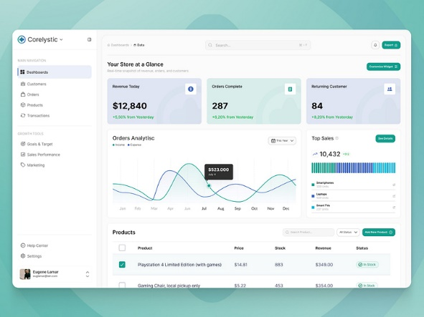
Layout:
Horizontal table:
Columns = Machines
Rows = Specifications
Sticky first column.
CTA at bottom:
Request Quote for Selected
This builds platform differentiation.

SELLER DASHBOARD

1️⃣ Seller Sidebar Structure
🏠 Overview
📦 My Listings
➕ Add Equipment
📨 Buyer Inquiries
📑 RFQ Responses
📊 Analytics
⭐ Featured Upgrades
💬 Messages
🏷 Verification Status
⚙ Settings

2️⃣ Seller Overview Page

KPI Cards Row
- Total Listings
- Active Inquiries
- RFQ Invites
- Conversion Rate
- Profile Views
Add trend arrows (↑ ↓)

Middle Section – Performance Chart
Graph:
Inquiries over last 30 days.
Below:
Top performing machine listings.

Right Side Panel:
Profile Strength Meter:
- GST Verified
- Documents uploaded
- Factory photos added
- Response time score
Gamify trust.

3️⃣ My Listings Page
Grid layout of machine cards.
Each card:
- Machine photo
- Price
- Status (Active / Draft / Paused)
- Views
- Inquiries
- Edit button
Top right:
- Add New Listing (Primary CTA)

4️⃣ Add Equipment Form (Critical UX)
Multi-step process:
Step 1: Basic Info
Step 2: Technical Specs
Step 3: Pricing & Warranty
Step 4: Upload Photos / Video
Step 5: Verification Documents
Right side preview panel:
Live listing preview.

5️⃣ Buyer Inquiries Panel
Table layout:
Columns:
- Buyer Name
- Location
- Machine
- Message preview
- Date
- Status
- Reply button
Filter:
Unread / High priority / Negotiation stage

6️⃣ RFQ Response Interface
Similar to Buyer RFQ but reversed.
Seller sees:
- Buyer requirement
- Budget
- Location
- Attachments
Right panel:
Submit quote form:
- Price
- Lead time
- Warranty
- Additional notes
- Attach technical sheet

7️⃣ Analytics Page
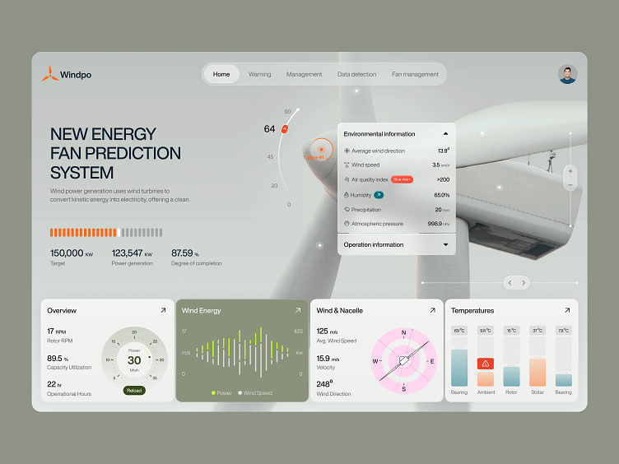
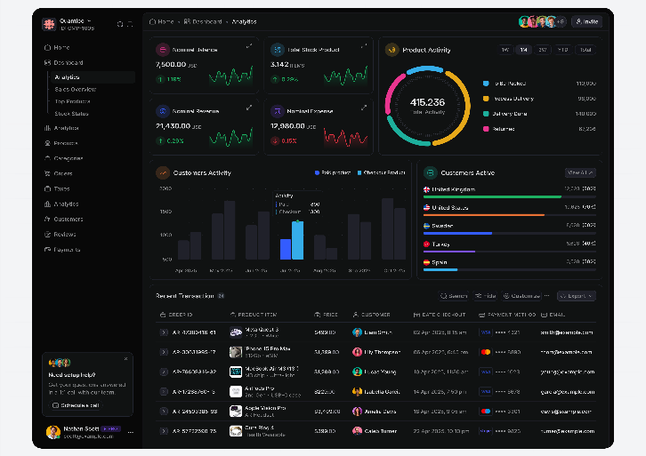
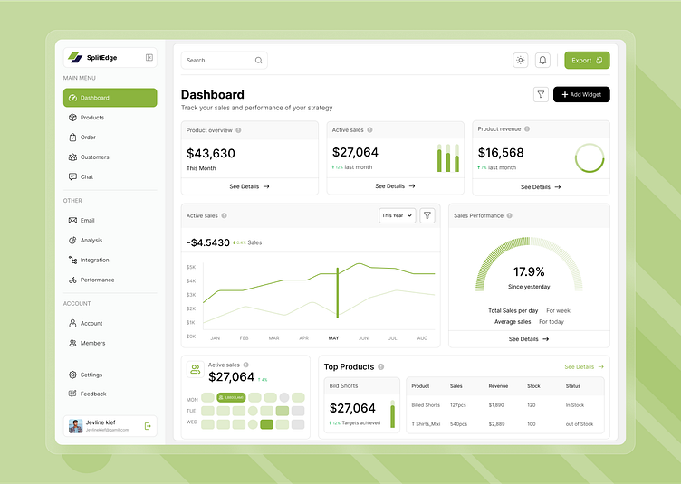
Metrics:
- Listing views
- Inquiry rate
- RFQ win rate
- Avg response time
- Region demand heatmap
Premium feature possibility:
Advanced analytics behind subscription.

VERIFICATION STATUS PANEL
Dedicated page:
Checklist:
- GST verified
- ISO certificate uploaded
- Factory video uploaded
- Years in business
- On-site verification (future)
Badge levels:
Basic
Verified
Trusted Supplier
Premium Industrial Partner
This increases monetization.

UX & MICRO INTERACTIONS
Add:
- Hover tooltips explaining industrial terms
- Loading skeletons
- Smooth page transitions
- Sticky action buttons
- Notification bell with unread count
- Real-time updates (future)

Mobile Adaptation Strategy
Sidebar collapses to bottom nav.
Top 4 mobile actions:
Home
RFQ
Messages
Profile
Industrial buyers still use desktop mostly — optimize desktop first.

